**Lab Practical #01:**

Study of basic networking commands and IP configuration.

**Practical Assignment #01:**

1. Perform and explain various networking commands listed below:
   1. ipconfig
   2. ping
   3. getmac
   4. systeminfo
   5. traceroute / tracert
   6. netstat
   7. nslookup
   8. hostname
   9. pathping
   10. arp

## ipconfig

### Description:

ipconfig is a command-line utility in Windows operating systems used to display and manage the network configuration of a computer. It provides details about the IP address, subnet mask, default gateway, and other network information for each network adapter. Additionally, it allows users to release and renew DHCP-assigned IP addresses and manage DNS settings.

|  |  |  |
| --- | --- | --- |
| No. | Option | Description |
| 1 | /all | Display full configuration information. |
| 2 | /renew | Renew the IPv4 address for the specified adapter. |
| 3 | /release | Release the IPv4 address for the specified adapter. |
| 4 | /displaydns | Display the contents of the DNS Resolver Cache. |
| 5 | /flushdns | Purges the DNS Resolver cache. |

### Implementation:

* ipconfig

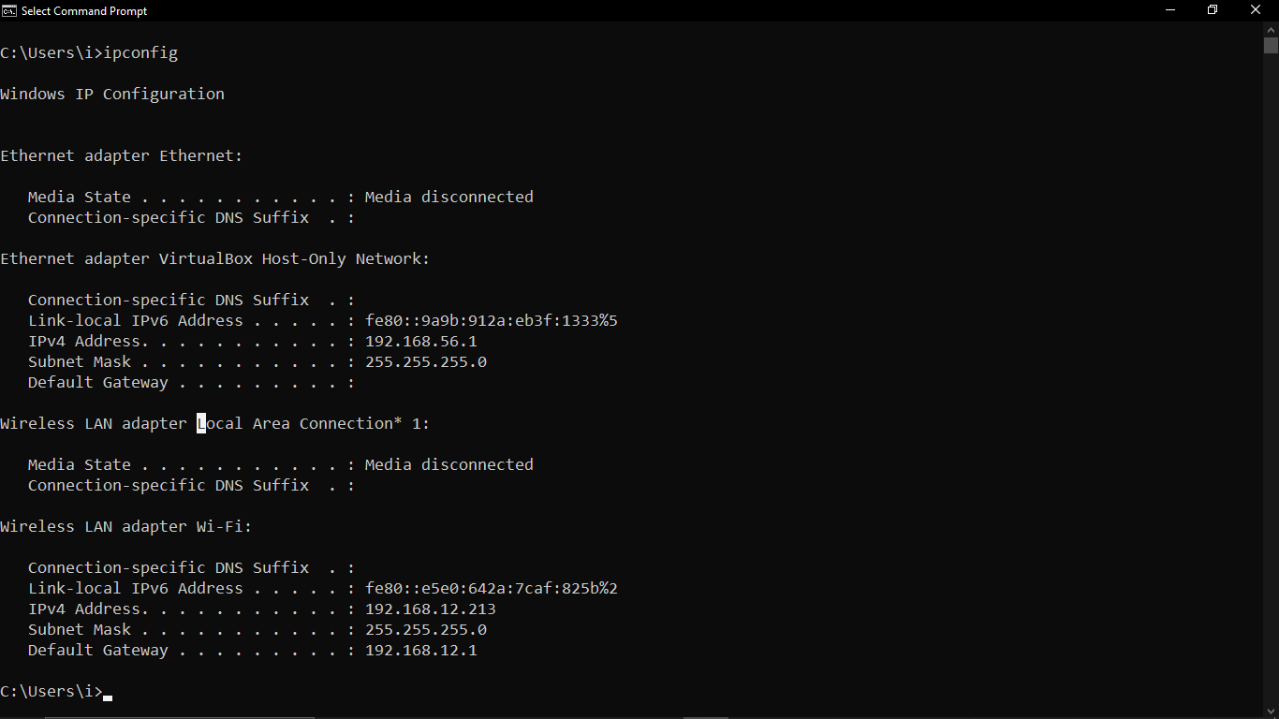

* ipconfig /all

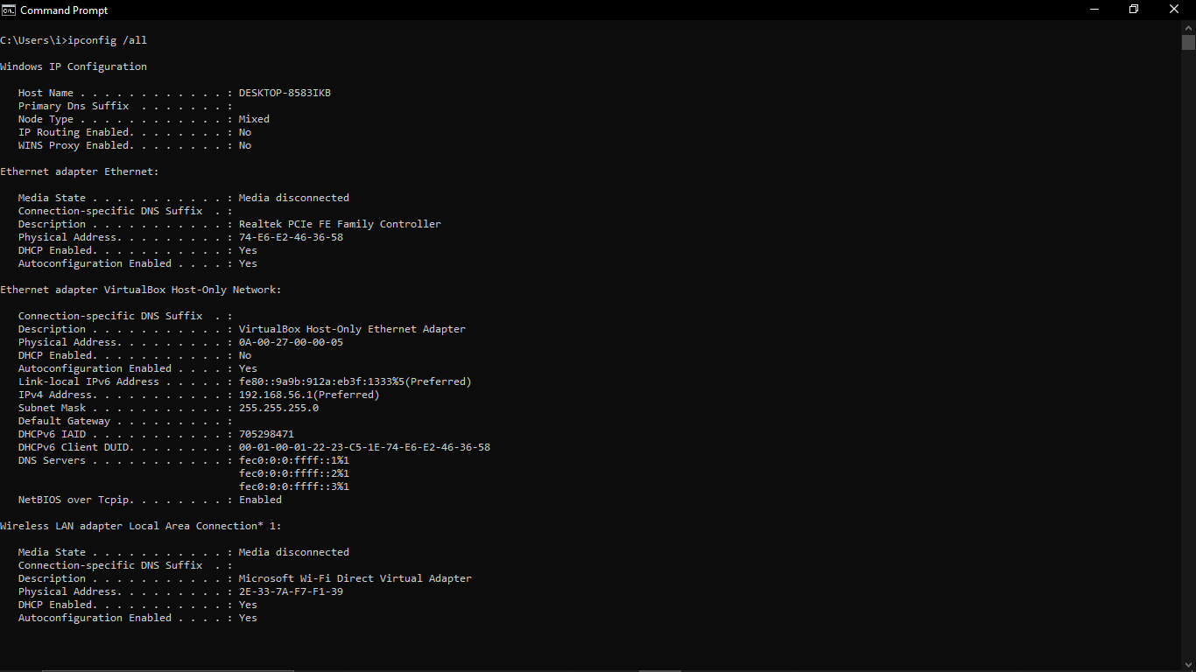

* ipconfig /release

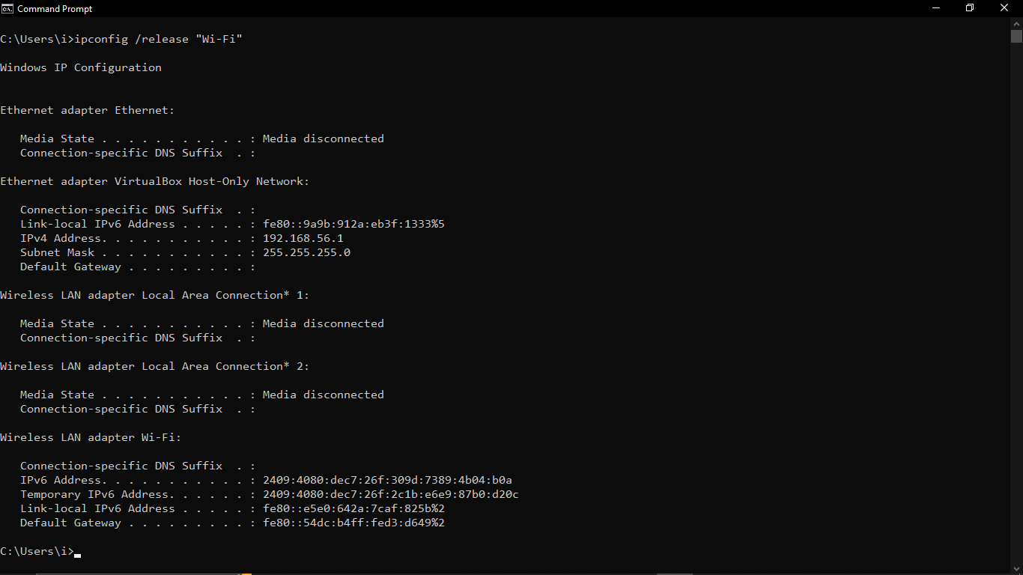

* ipconfig /renew

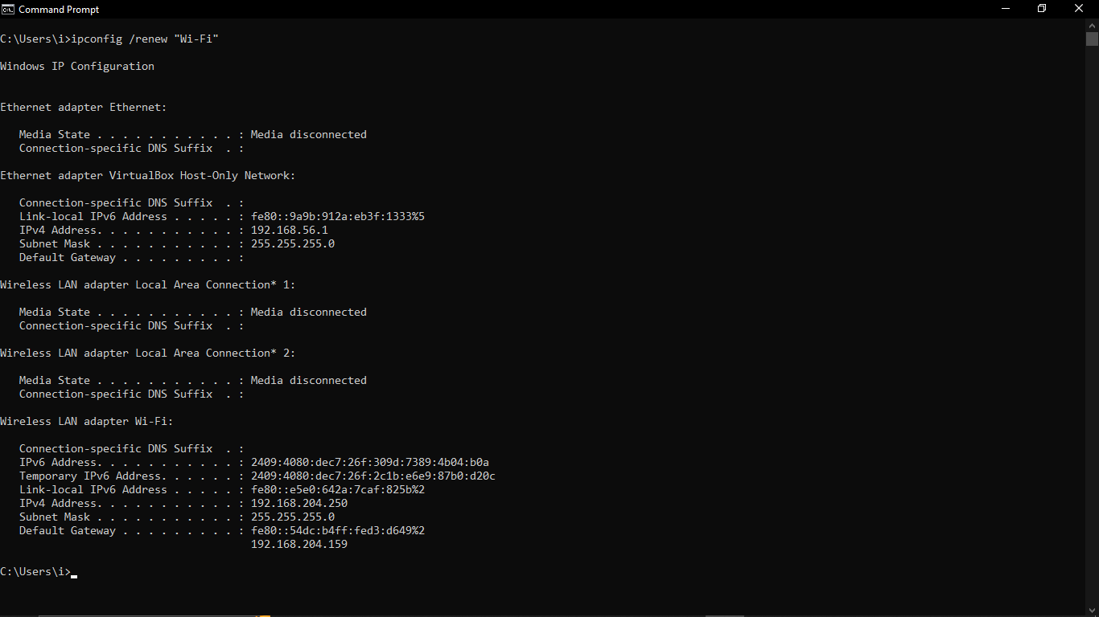

* ipconfig /displaydns

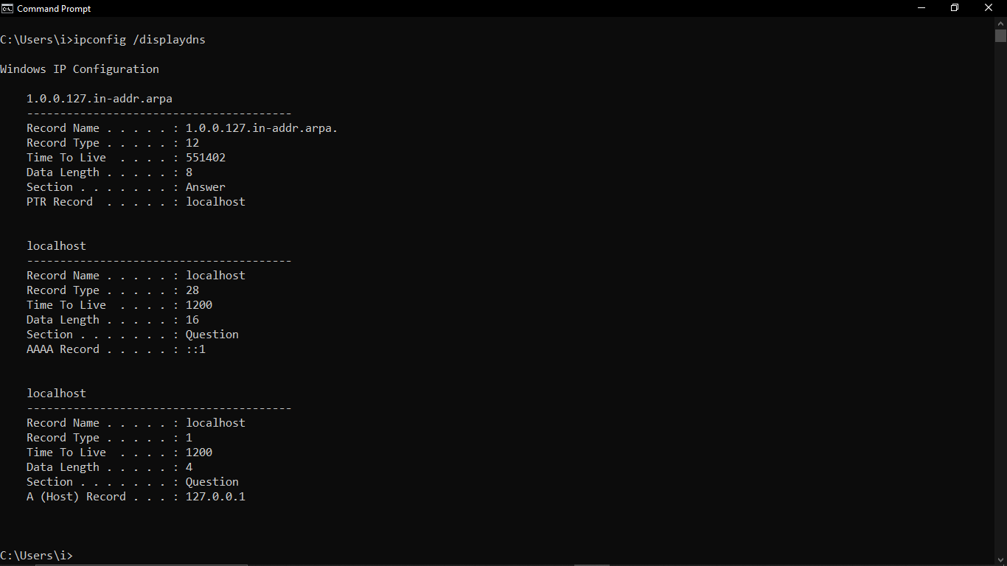

* ipconfig /flushdns

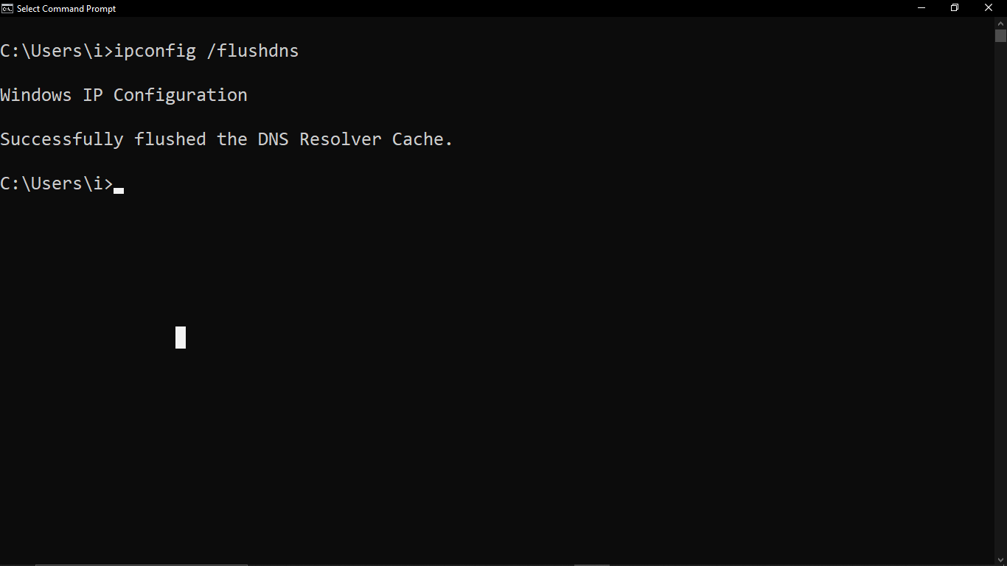

## ping

### Description:

The ping command is a network utility used to test the reachability of a host on an IP network. It also measures the round-trip time for messages sent from the originating host to a destination computer. This command is useful for diagnosing network connectivity issues.

|  |  |  |
| --- | --- | --- |
| No. | Option | Description |
| 1 | -t | Ping the specified host until stopped.  To see statistics and continue - type Control-Break. To stop - type Control-C. |
| 2 | -n count | Number of echo requests to send. |
| 3 | -l size | Send buffer size. |
| 4 | -4 | Force using IPv4. |
| 5 | -i TTL | Time To Live. |

### Implementation:

* ping www.google.com

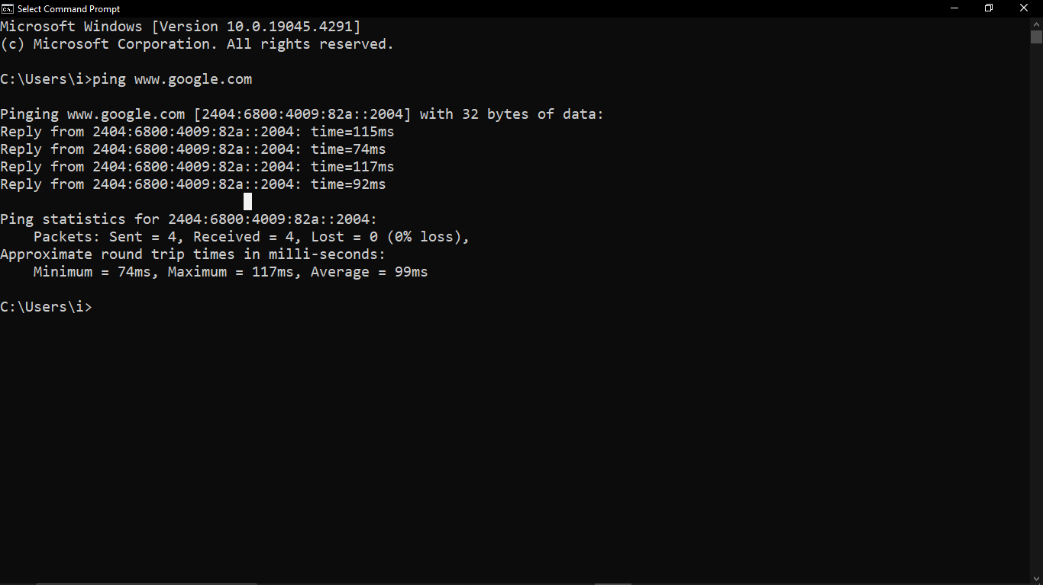

* ping [www.google.com](http://www.google.com) -t

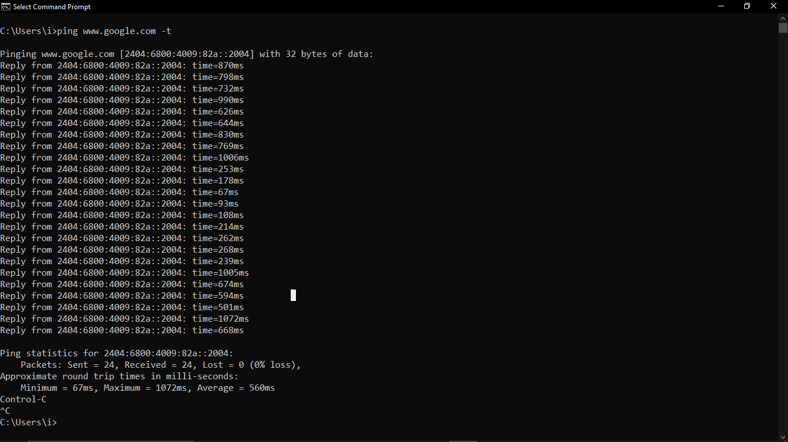

* ping [www.google.com](http://www.google.com) –n 10

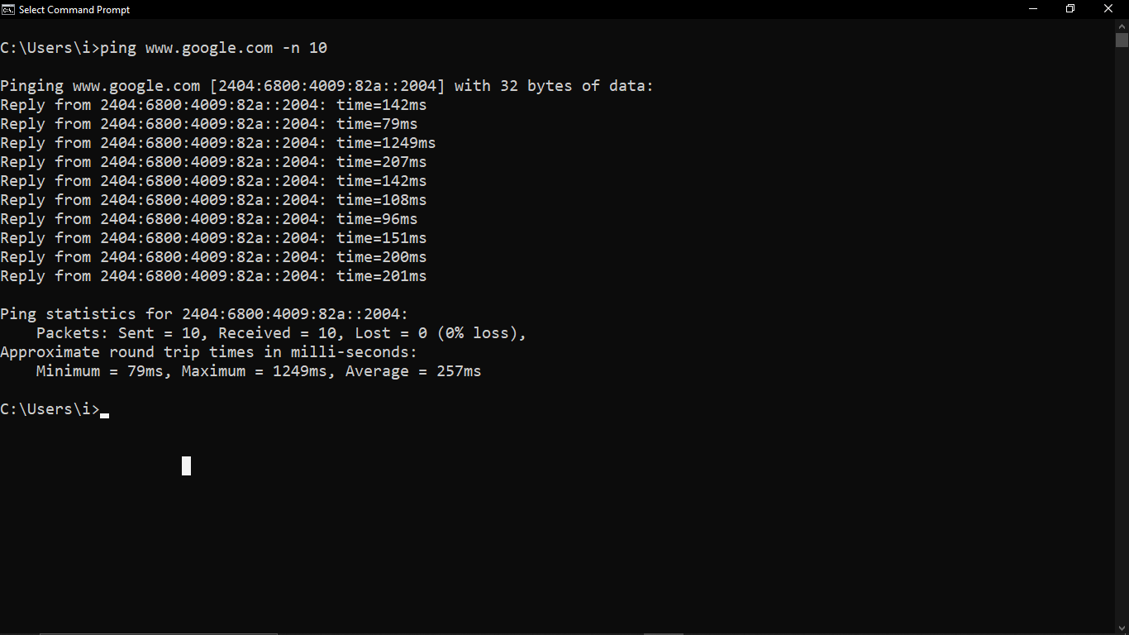

* ping [www.google.com](http://www.google.com) –l 1000

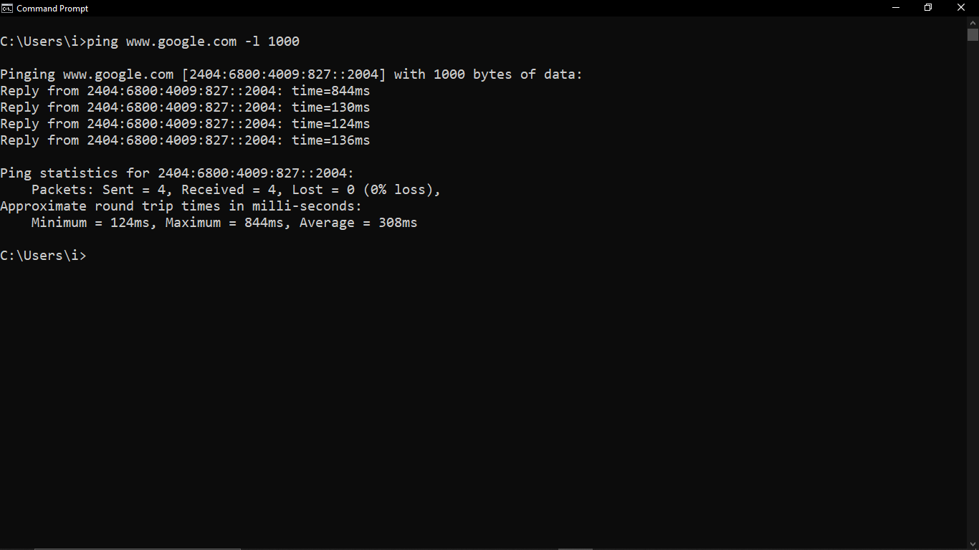

* ping [www.google.com](http://www.google.com) -4

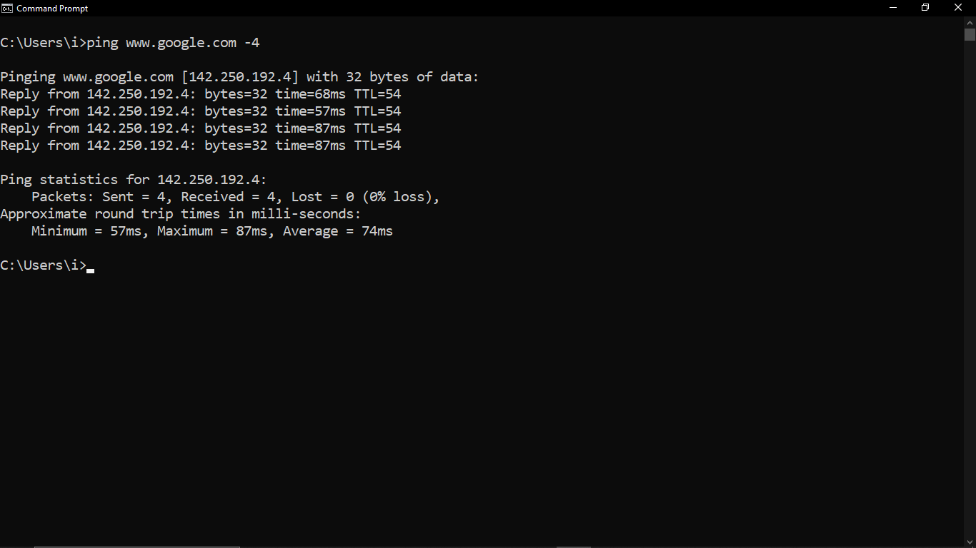

* ping -i 4 [www.google.com](http://www.google.com)

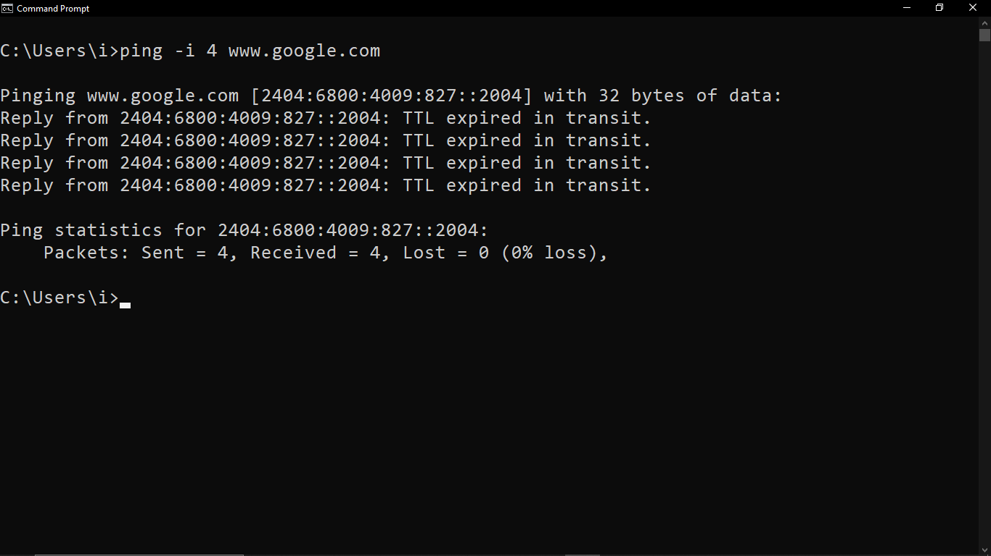

## getmac

### Description:

The getmac command is a command-line utility in Windows operating systems that displays the MAC addresses for network adapters on the system. The MAC address, or Media Access Control address, is a unique identifier assigned to network interfaces for communications at the data link layer of a network segment.

|  |  |  |
| --- | --- | --- |
| No. | Option | Description |
| 1 | /S system | Specifies the remote system to connect to. |
| 2 | /U [domain\]user | Specifies the user context under which the command should execute. |
| 3 | /V | Specifies that verbose output is displayed. |
| 4 | /FO format | Specifies the format in which the output is to be displayed.Valid values: "TABLE", "LIST", "CSV". |
| 5 | /NH | Specifies that the "Column Header" should not be displayed in the output.Valid only for TABLE and CSV formats. |

### Implementation:

* getmac

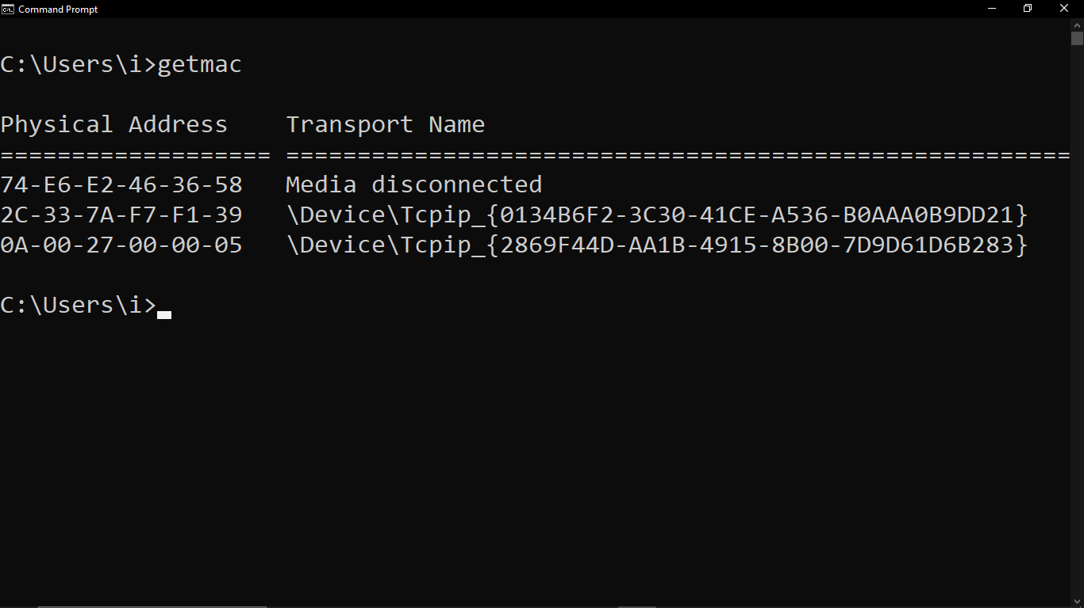

* getmac /FO TABLE

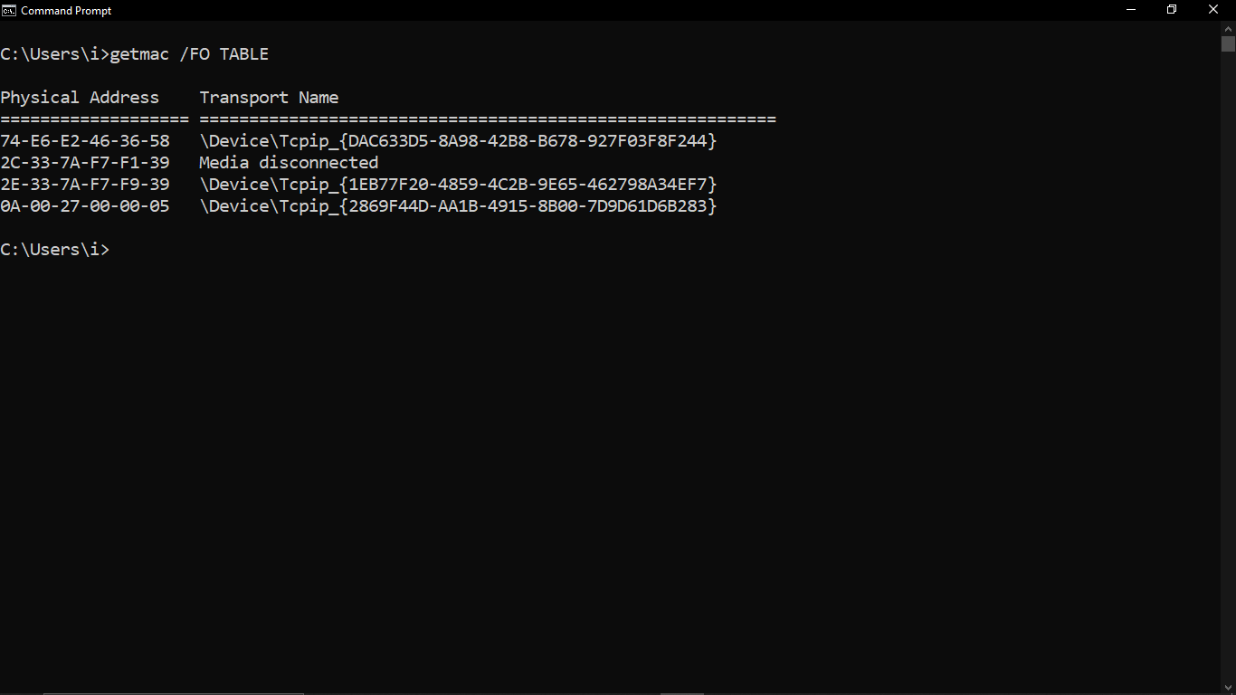

* getmac /FO LIST

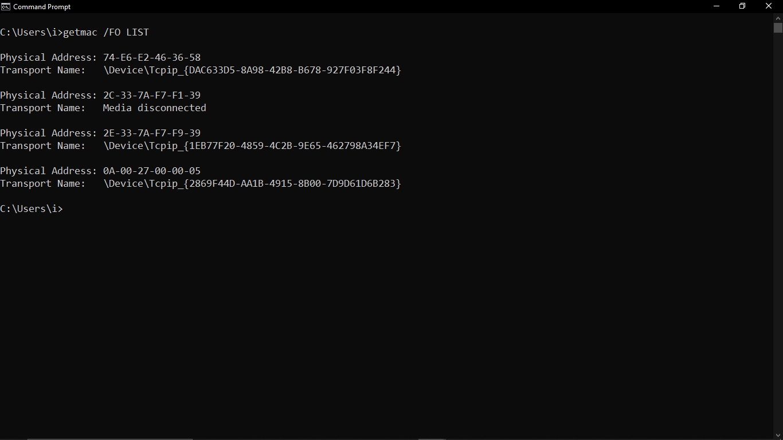

* getmac /FO CSV

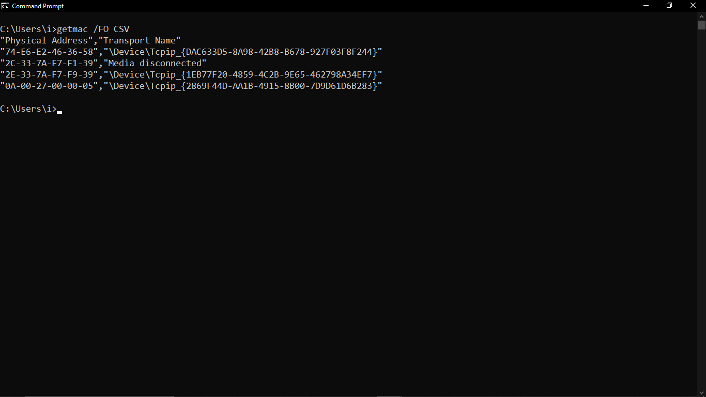

* getmac /FO CSV /NH

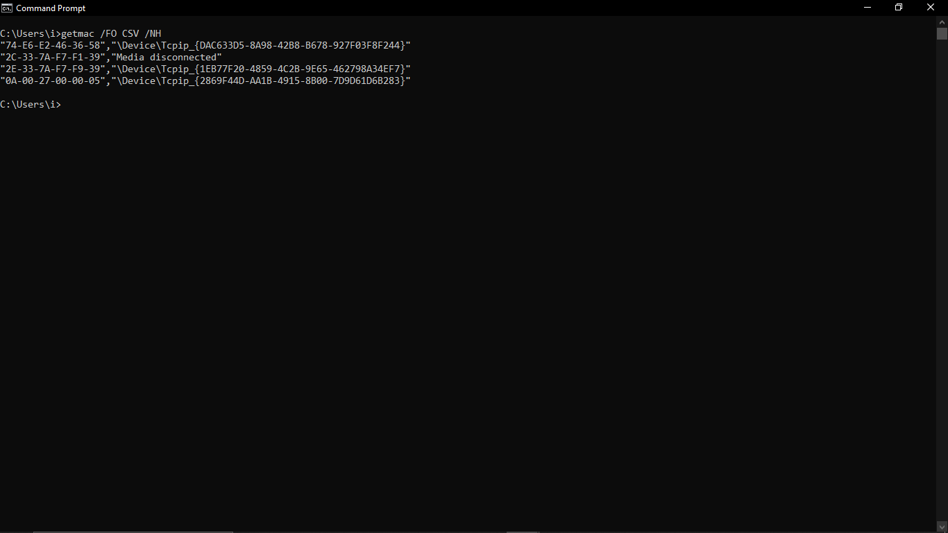

* getmac /v

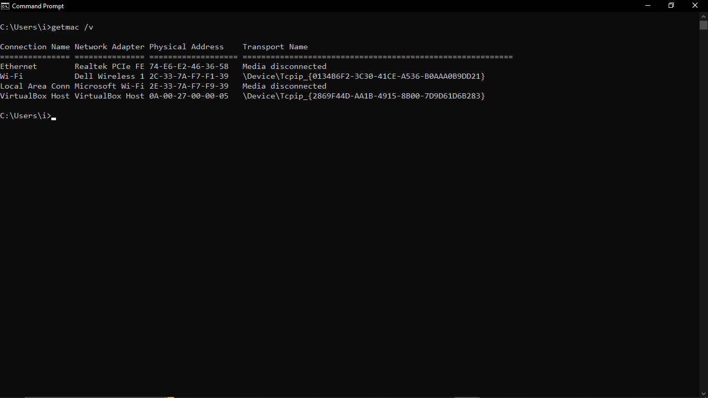

## systeminfo

### Description:

systeminfo is a command-line utility in Microsoft Windows that provides detailed information about the system's configuration. It gathers and displays various parameters related to the operating system, hardware, and software environment

|  |  |  |
| --- | --- | --- |
| No. | Option | Description |
| 1 | /S system | Specifies the remote system to connect to. |
| 2 | /U [domain\]user | Specifies the user context under which the command should execute. |
| 3 | /P [password] | Specifies the password for the given user context. Prompts for input if omitted. |
| 4 | /FO format | Specifies the format in which the output is to be displayed.Valid values: "TABLE", "LIST", "CSV". |
| 5 | /NH | Specifies that the "Column Header" should not be displayed in the output. Valid only for "TABLE" and "CSV" formats. |

### Implementation:

* systeminfo

## 

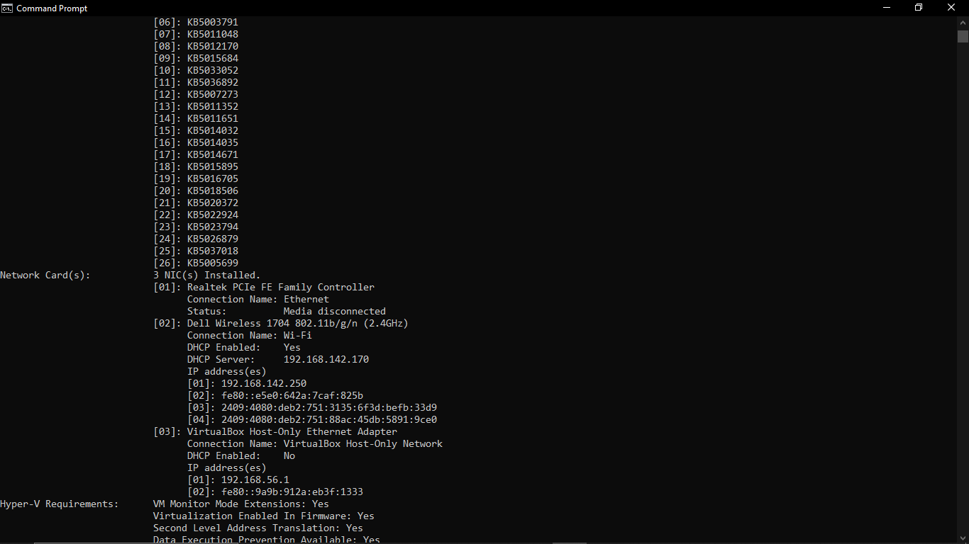

* systeminfo /FH TABLE

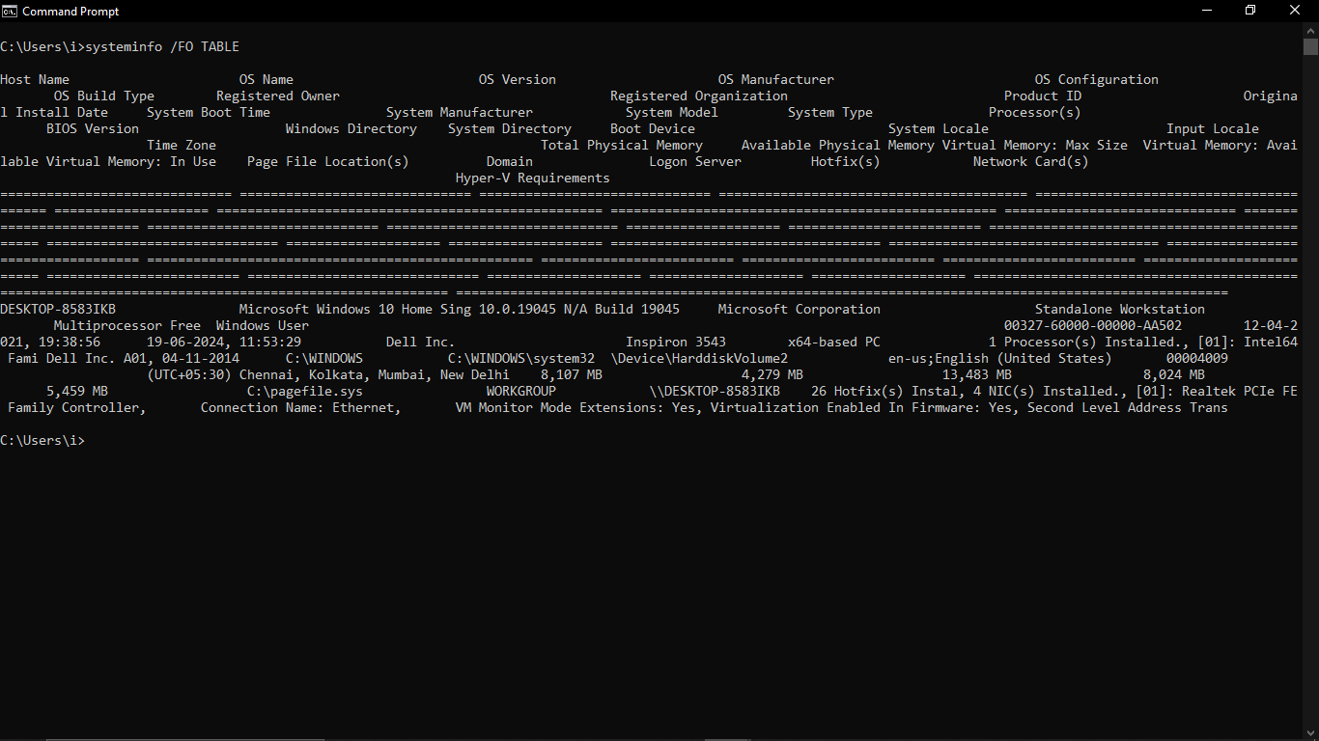

* systeminfo /FO CSV

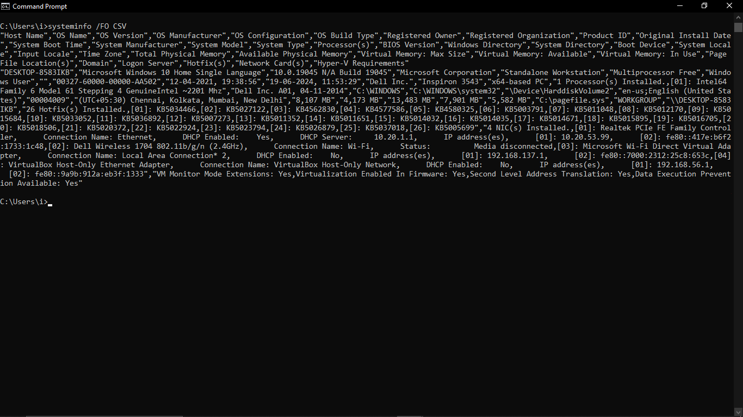

* systeminfo /NH

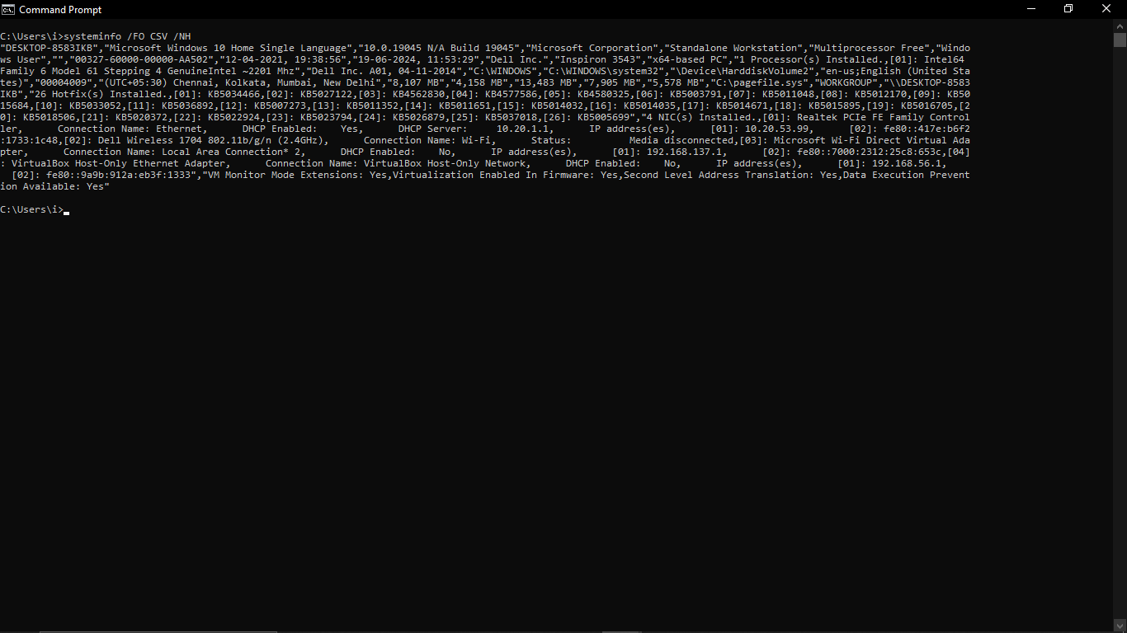

## traceroute/tracert

### Description:

The tracert command (short for "trace route") is a network diagnostic tool available in Windows operating systems. It is used to determine the path packets take from your computer to a destination host. This command helps in identifying where in the network the issues are occurring, such as delays or failures in data transmission.

|  |  |  |
| --- | --- | --- |
| No. | Option | Description |
| 1 | -d | Do not resolve addresses to hostnames. |
| 2 | -h maximum_hops | Maximum number of hops to search for target. |
| 3 | -w timeout | Wait timeout milliseconds for each reply. |
| 4. | -S srcaddr | Source address to use (IPv6-only). |
| 5 | -4 | Force using IPv4. |

### Implementation:

* tracert www.google.com

## 

* tracert –d www.google.com

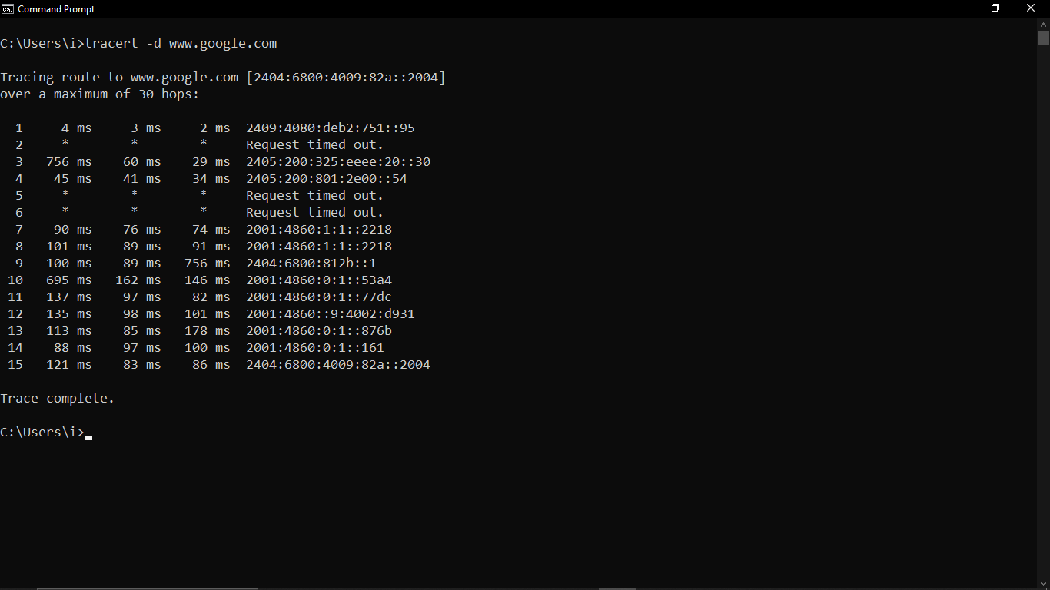

* tracert –h 3 www.google.com

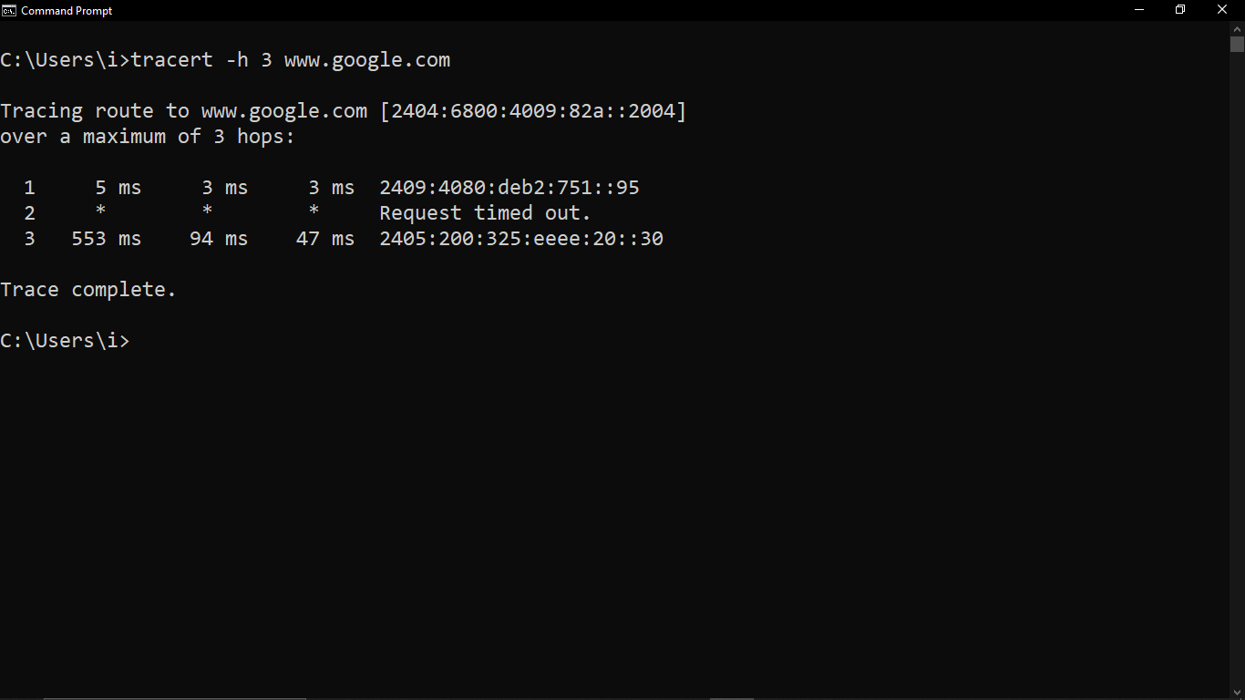

* tracert –w 3000 www.google.com

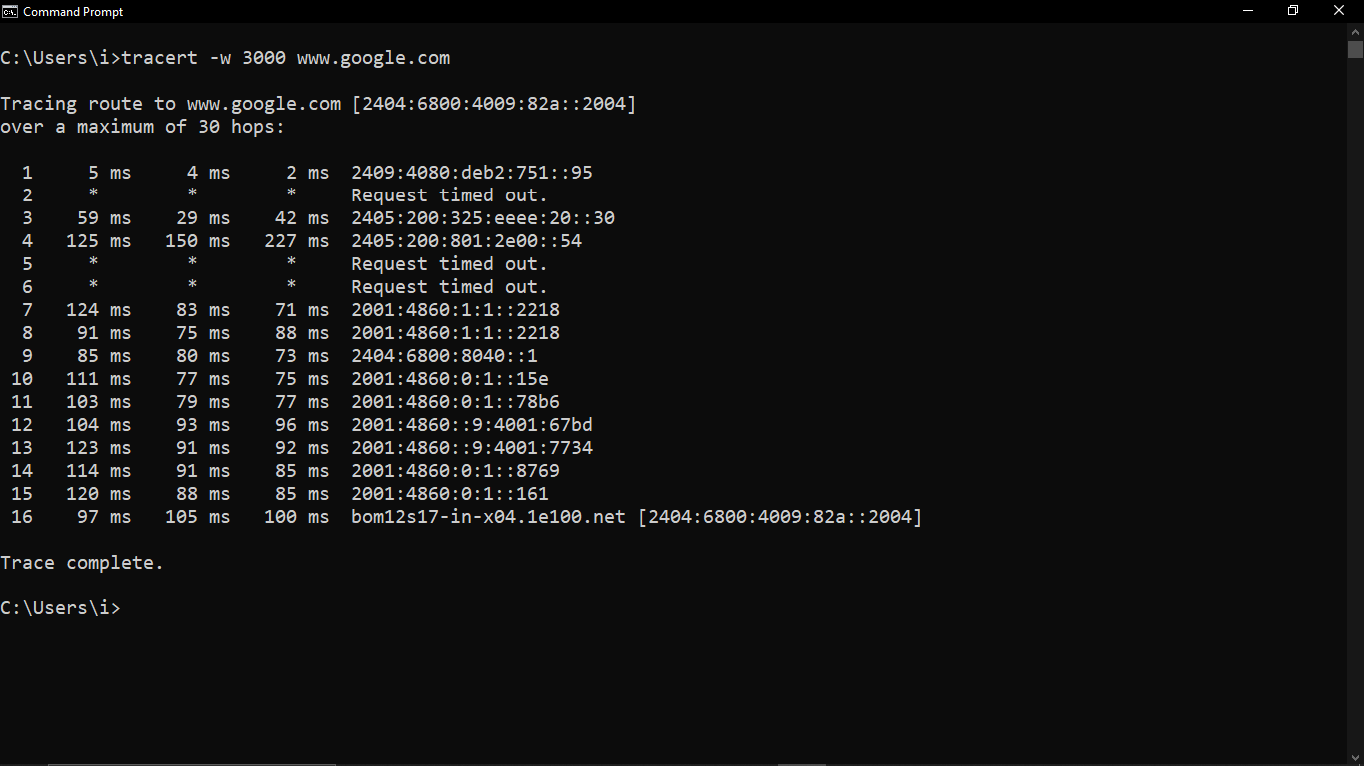

* tracert –S 2001:0db8:85a3:0000:0000:8a2e:0370:7334 ipv6.google.com

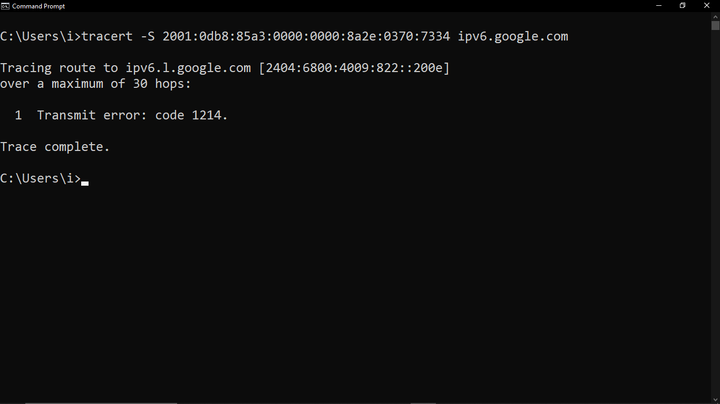

* tracert –4 www.google.com

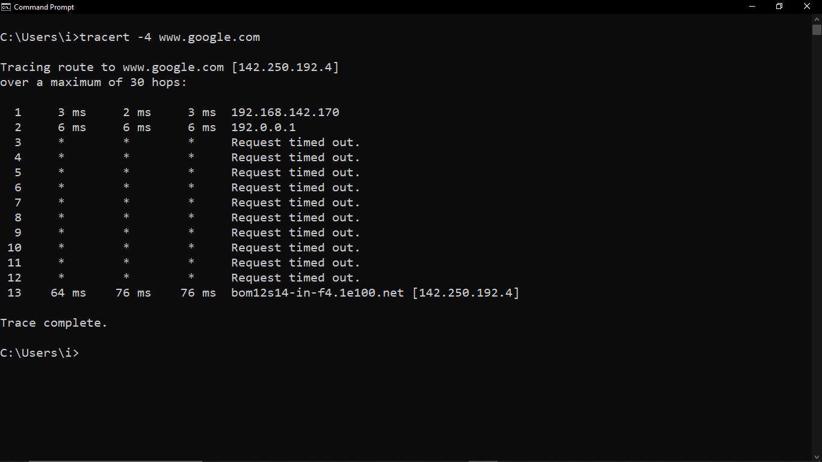

## netstat

### Description:

The netstat command is a network utility that displays network connections, routing tables, interface statistics, masquerade connections, and multicast memberships. It is available in various operating systems including Windows, Linux, and macOS. The command is useful for network troubleshooting and performance monitoring.

|  |  |  |
| --- | --- | --- |
| No. | Option | Description |
| 1 | -a | Displays all connections and listening ports. |
| 2 | -e | Displays Ethernet statistics. This may be combined with the –s option. |
| 3 | -f | Displays Fully Qualified Domain Names (FQDN) for foreign addresses. |
| 4 | -o | Displays the owning process ID associated with each connection |
| 5 | -r | Displays the routing table. |

### Implementation:

## 

* netstat -a

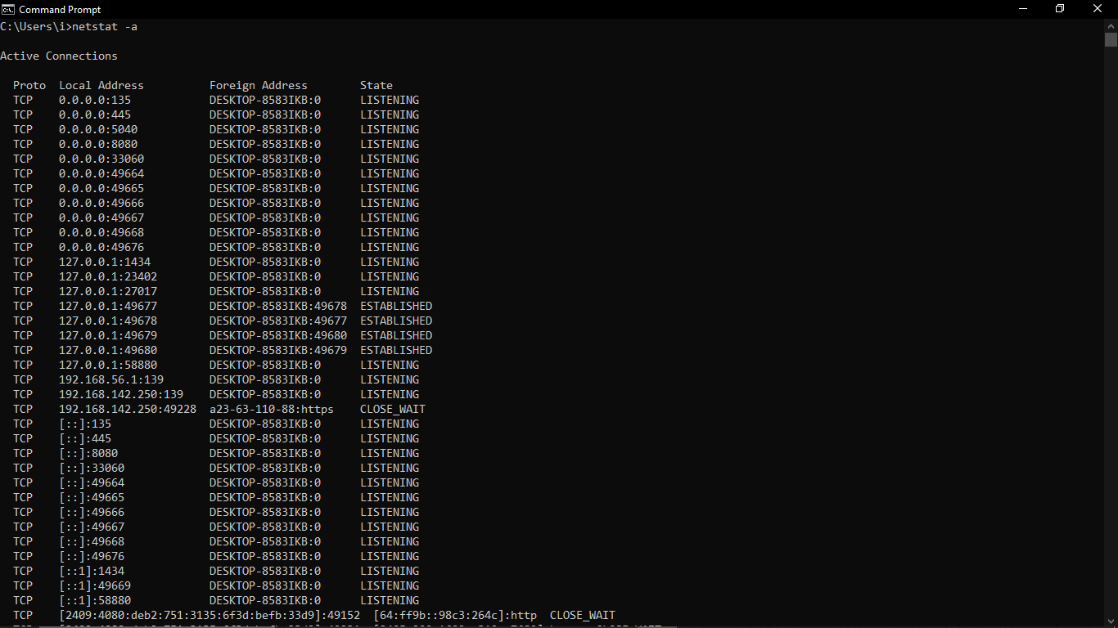

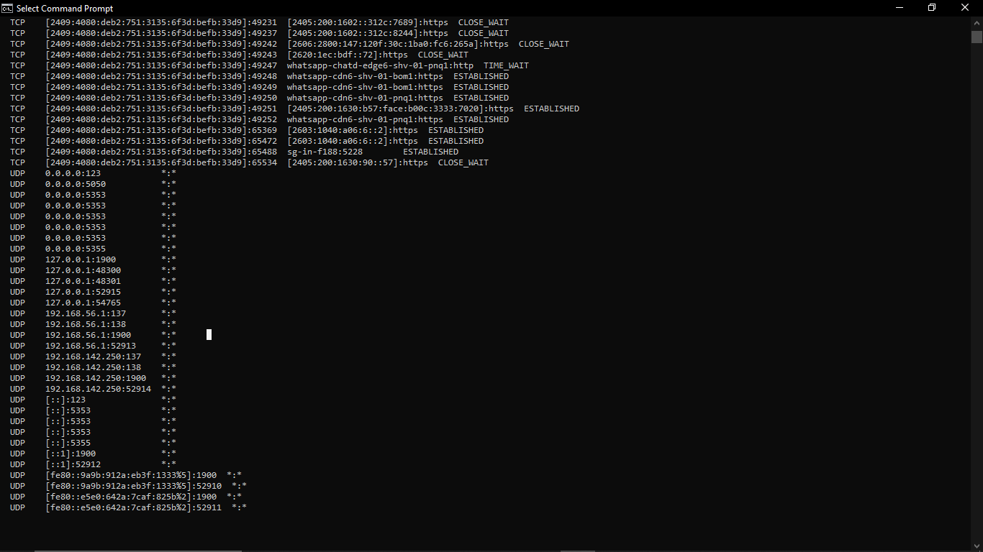

* netstat -e

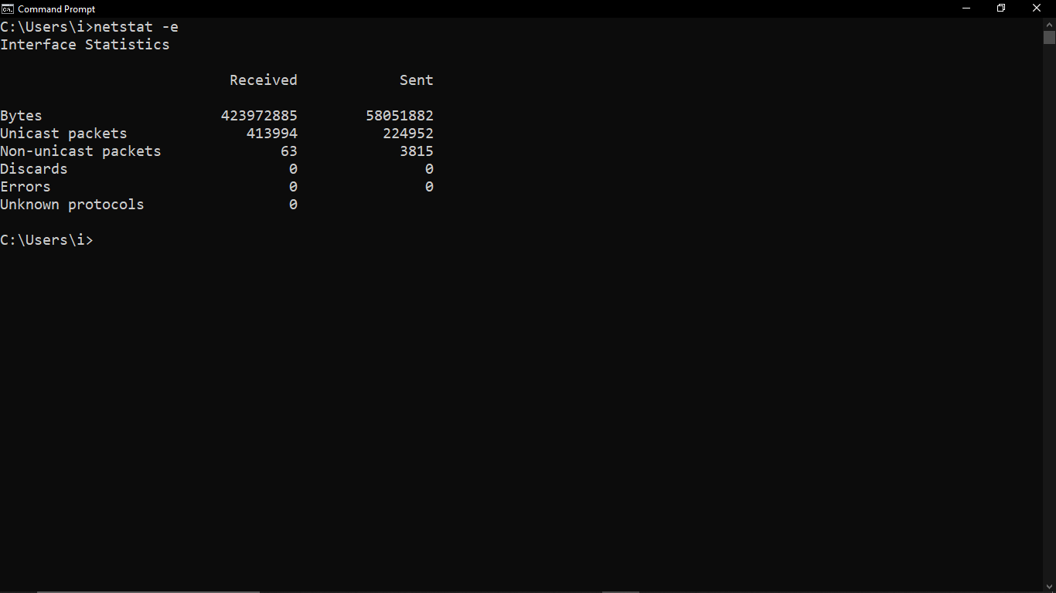

* netstat -f

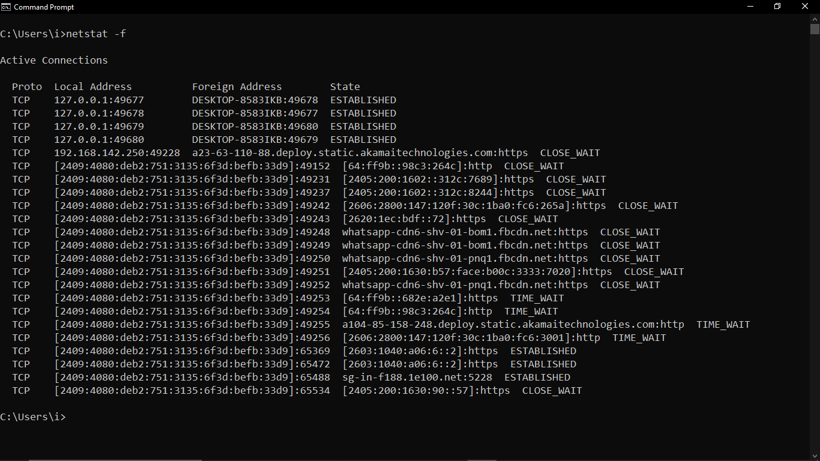

* netstat -o

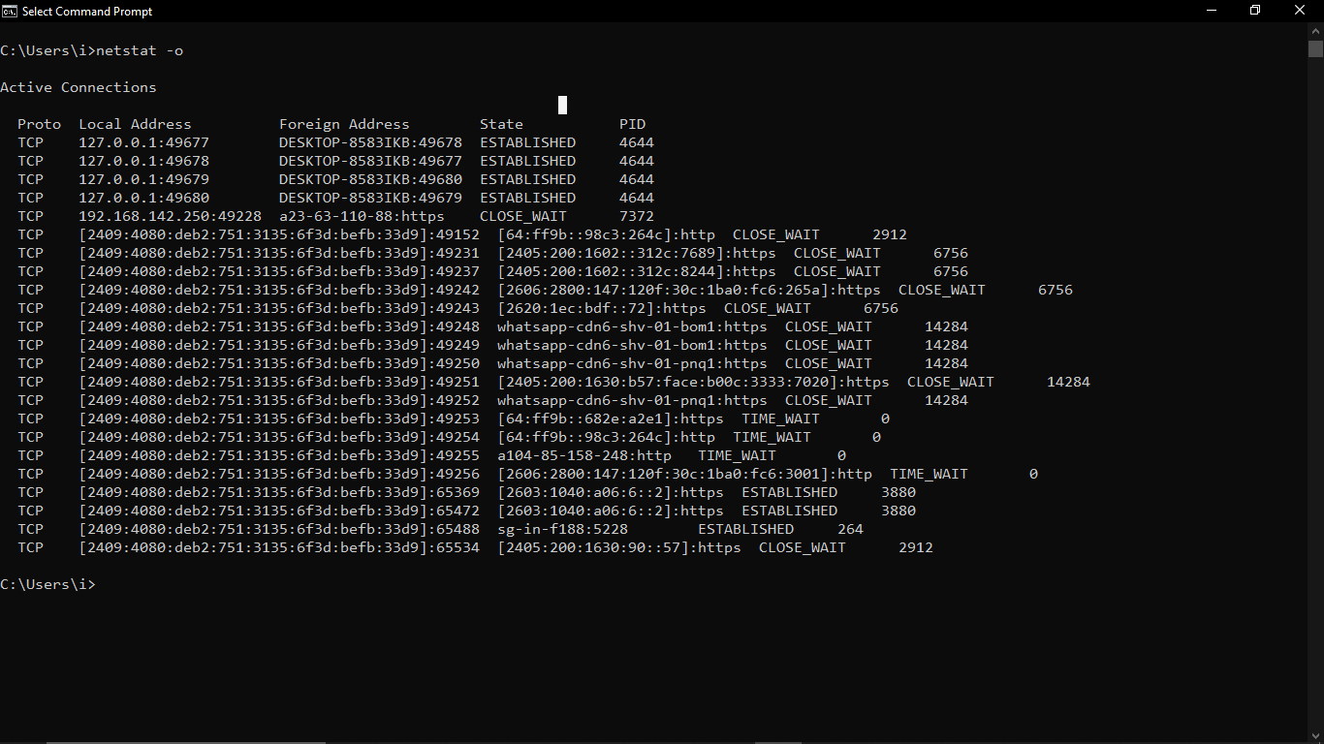

* netstat -r

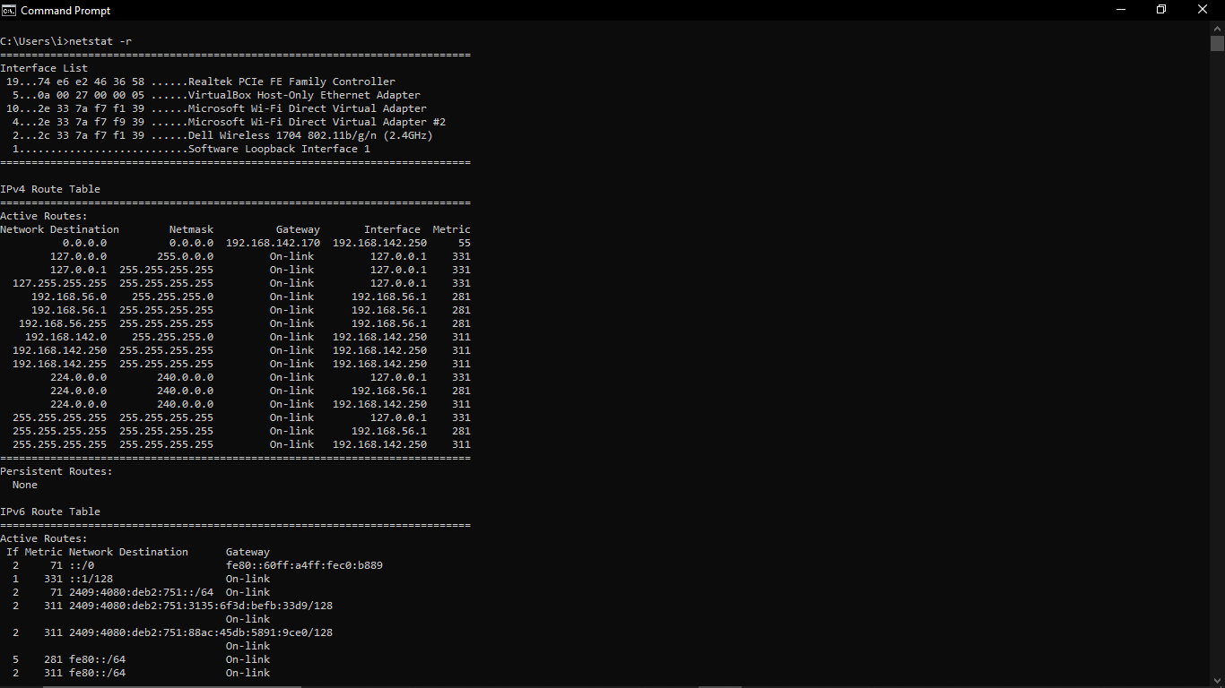

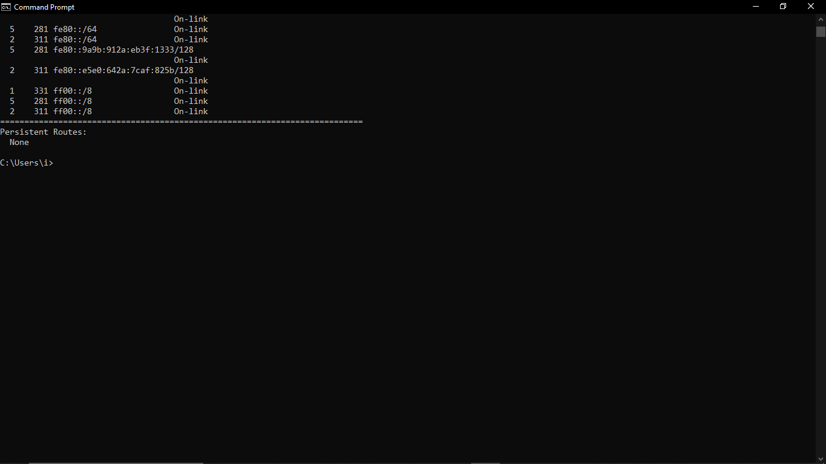

## nslookup

### Description:

### The nslookup command is a network administration command-line tool used for querying the Domain Name System (DNS) to obtain domain name or IP address mapping information. It can be used to find the IP address associated with a domain name or the domain name associated with an IP address. This tool is useful for diagnosing DNS issues and verifying DNS configurations.

|  |  |  |
| --- | --- | --- |
| No. | Option | Description |
| 1 | -debug | Enables the display of debugging information |
| 2 | -type=any | Lookup for any record We can also view all the available DNS records using the -type=any option. |
| 3 | -type=SOA | Lookup for a soa record SOA record (start of authority), provides the authoritative information about the domain, the e-mail address of the domain admin, the domain serial number, etc… |

### Implementation:

* nslookup www.google.com

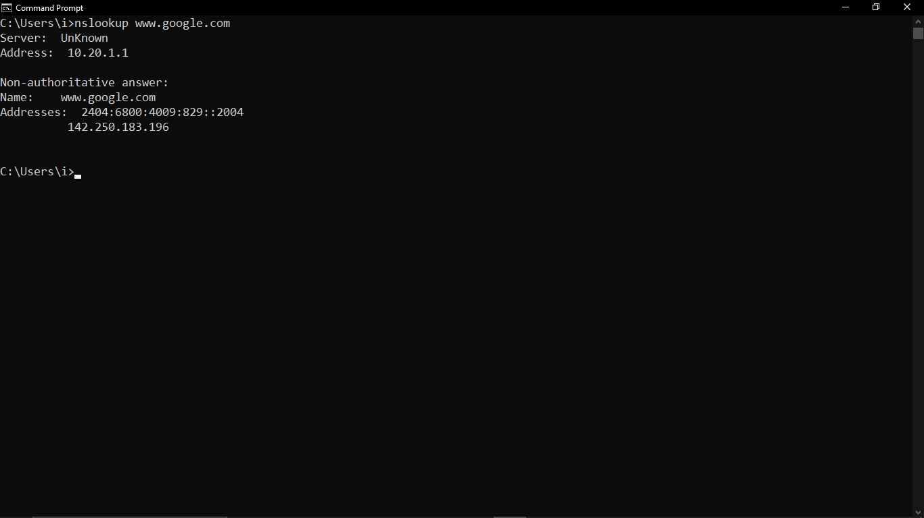

* nslookup –type=any [www.google.com](http://www.google.com)

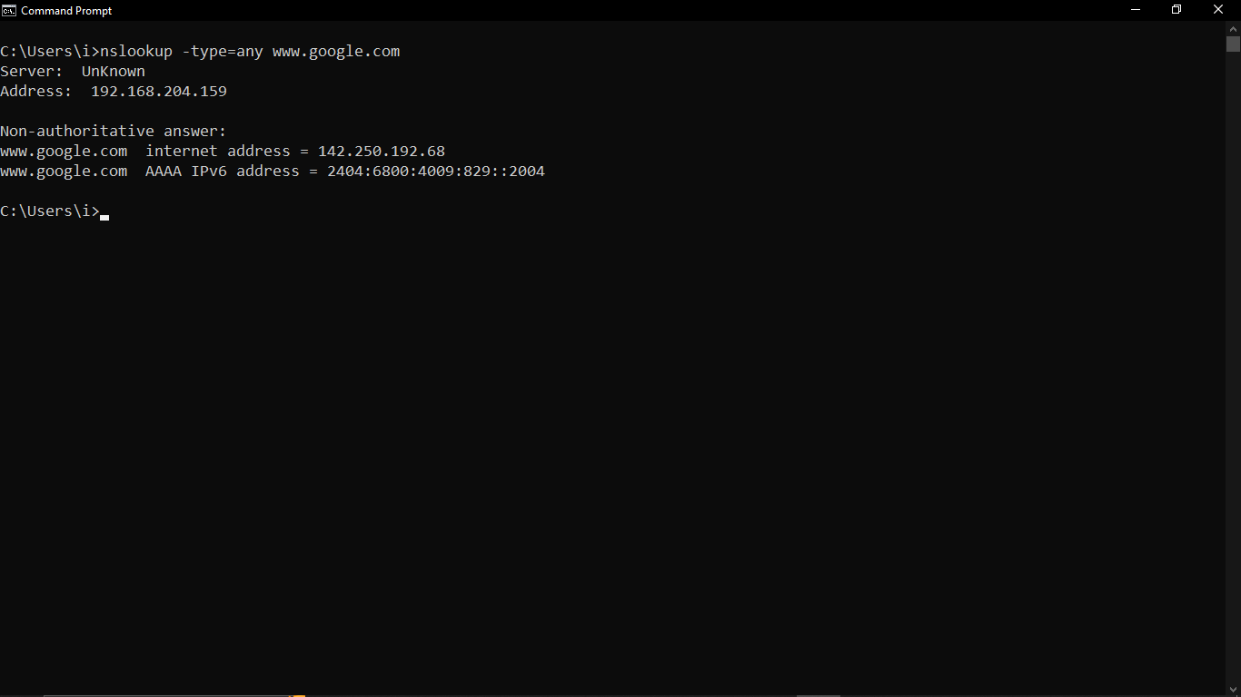

* nslookup –type=SOA [www.google.com](http://www.google.com)

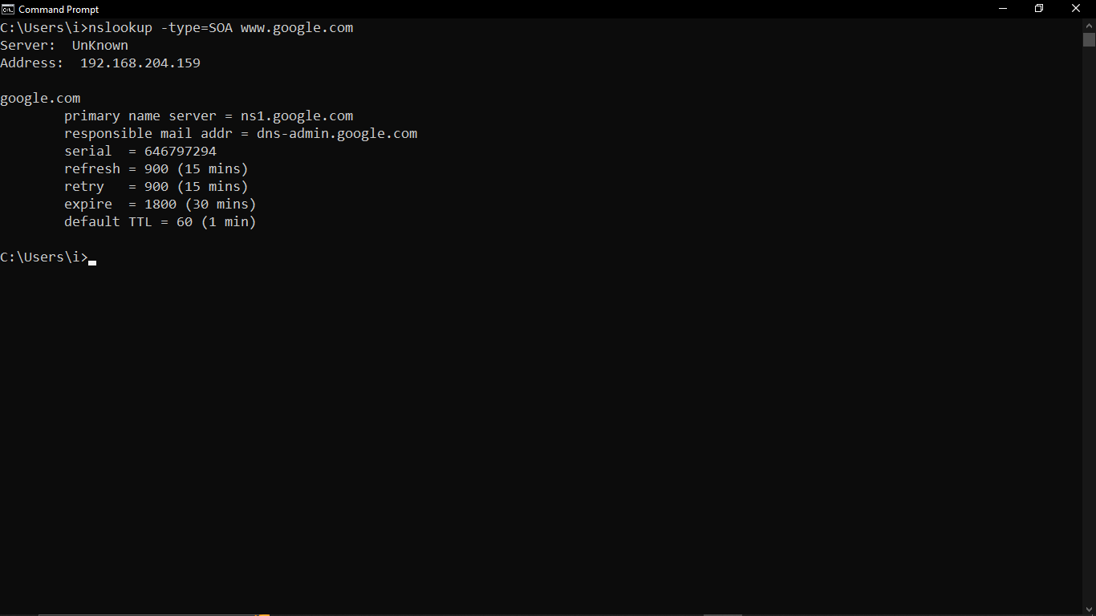

* nslookup –debug [www.google.com](http://www.google.com)



## hostname

### Description:

The hostname command is a simple command-line utility used in various operating systems (Windows, Linux, macOS) to display or set the name of the current host system. The hostname is a unique identifier assigned to a machine on a network.

### Implementation:

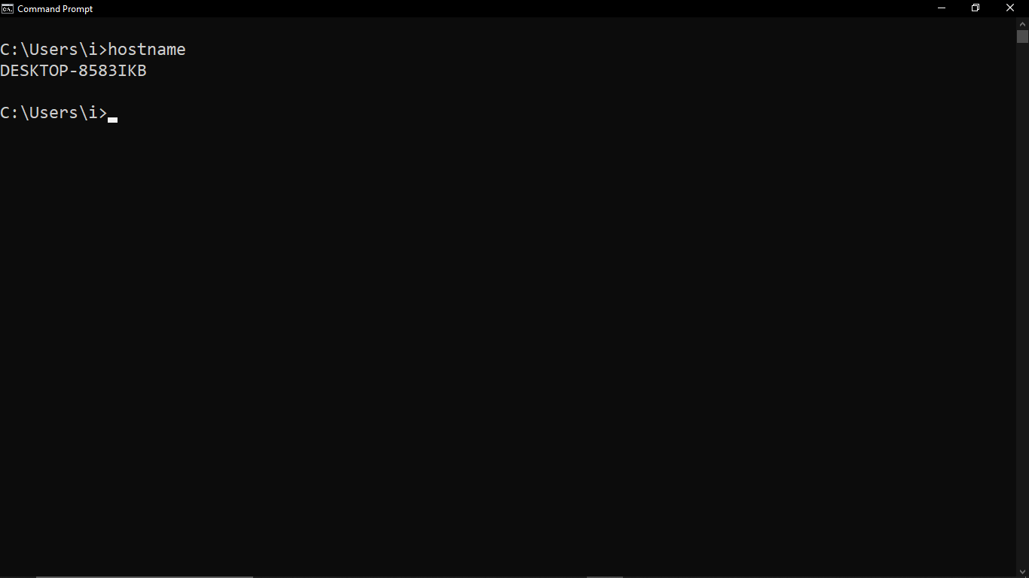

## pathping

### Description:

The pathping command in Windows is a network diagnostic tool that combines the features of ping and tracert. It provides detailed information about network latency and packet loss along the route from the source to the destination. This tool is particularly useful for identifying problematic routers or links in a network path.

|  |  |  |
| --- | --- | --- |
| No. | Option | Description |
| 1 | -h maximum_hops | Maximum number of hops to search for target. |
| 2 | -n | Do not resolve addresses to hostnames. |
| 3 | q num_queries | Number of queries per hop. |
| 4 | -w timeout | Wait timeout milliseconds for each reply. |
| 5 | -4 | Force using IPv4. |

### Implementation:

* pathping www.google.com

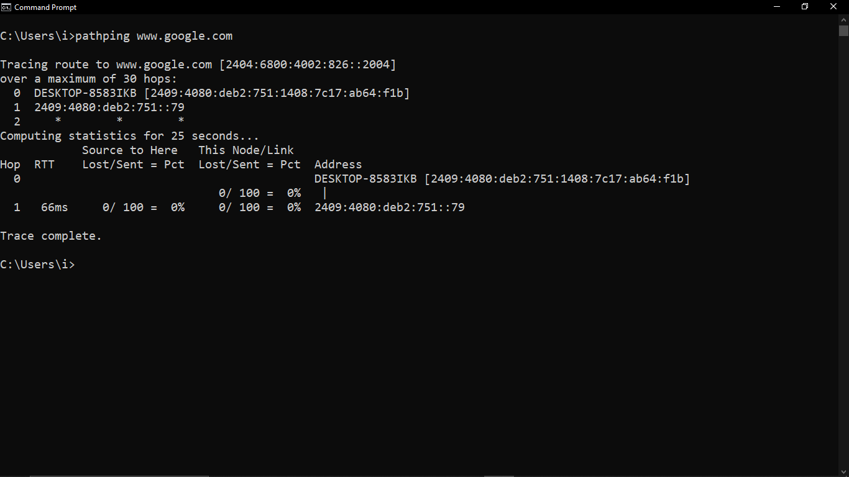

* pathping –h 5 www.google.com

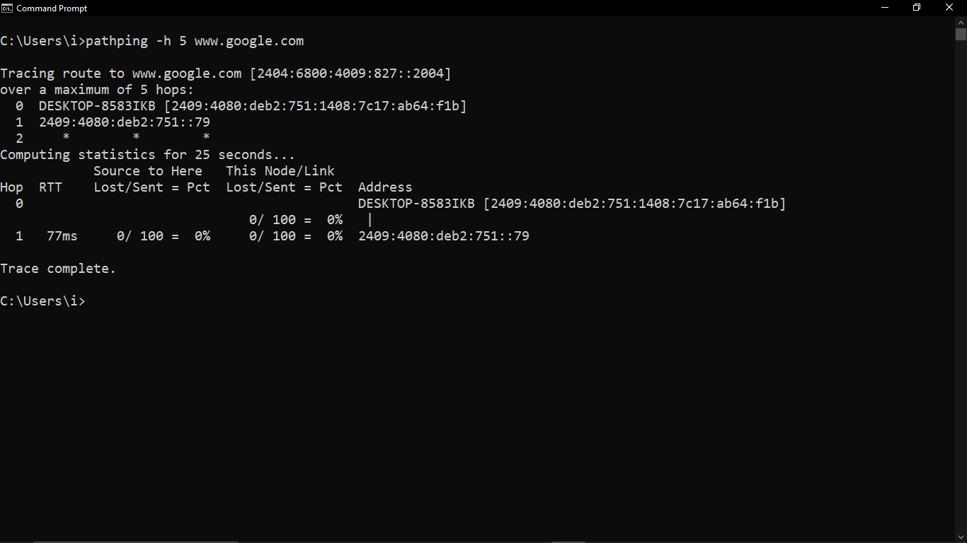

* pathping –n www.google.com

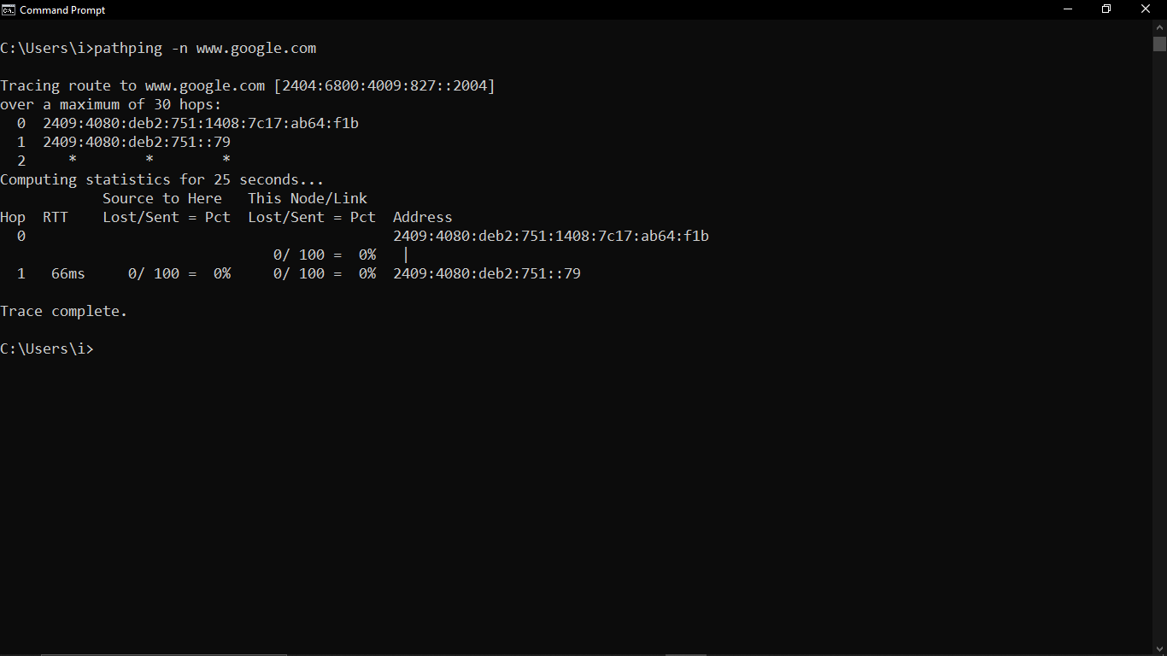

* pathping –q 5 www.google.com

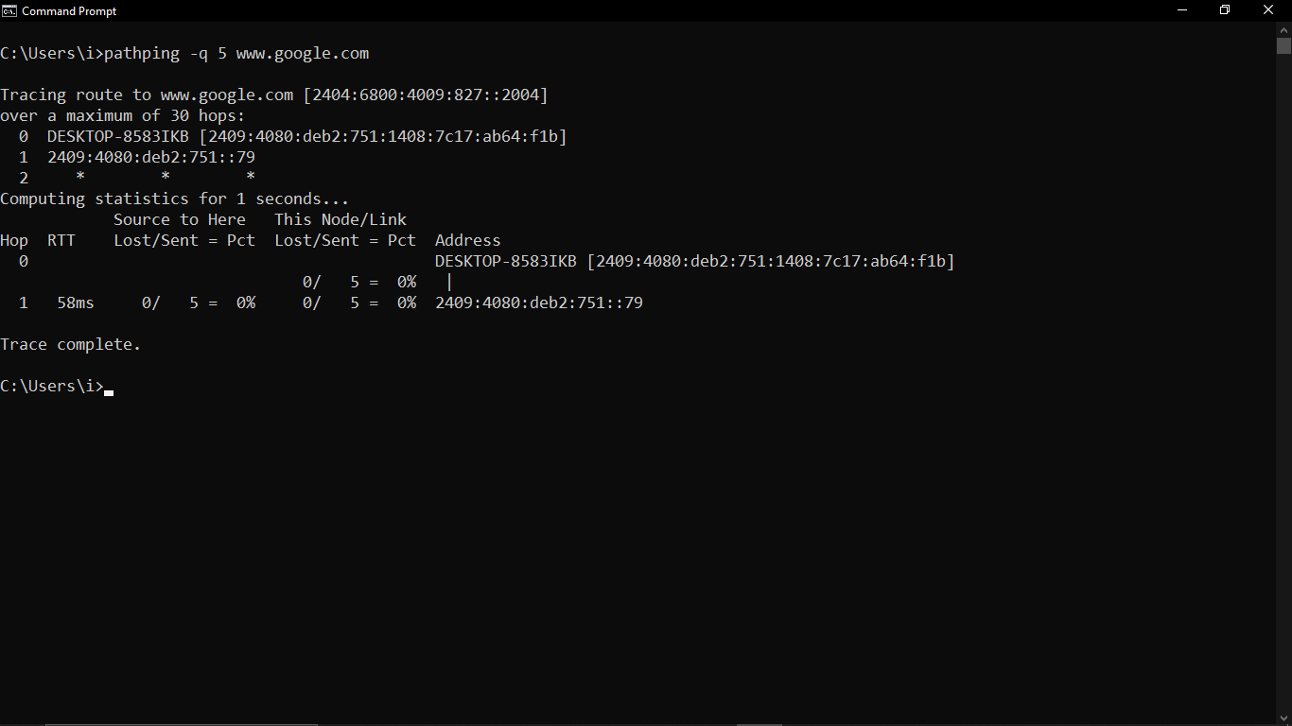

* pathping –w 3000 www.google.com

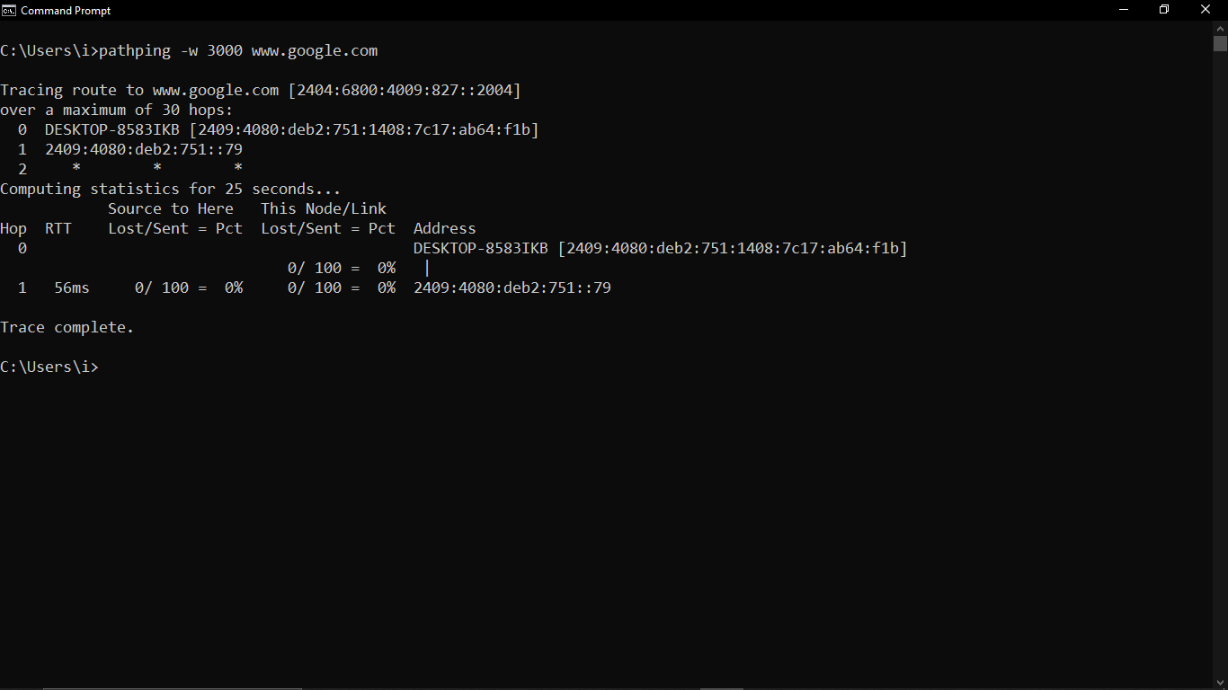

* pathping -4 www.google.com

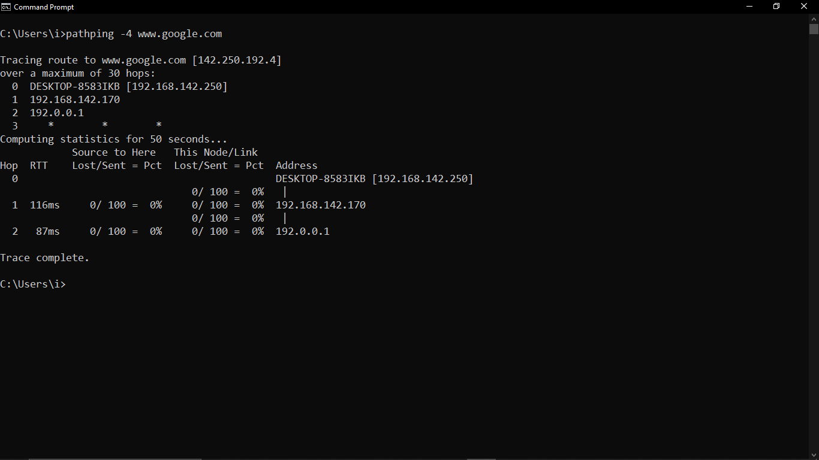

## arp

### Description:

The arp (Address Resolution Protocol) command in Windows is used to view and manipulate the ARP cache, which stores mappings of IP addresses to physical MAC addresses. This command is useful for diagnosing network issues and ensuring proper network configuration.

|  |  |  |
| --- | --- | --- |
| No. | Option | Description |
| 1 | -a | Displays current ARP entries by interrogating the currentprotocol data. If inet_addr is specified, the IP and Physical addresses for only the specified computer are displayed. If more than one network interface uses ARP, entries for each ARP table are displayed. |
| 2 | -v | Displays current ARP entries in verbose mode. All invalid entries and entries on the loop-back interface will be shown. |
| 3 | inet_addr. | Specifies an internet address |

### Implementation:

* arp

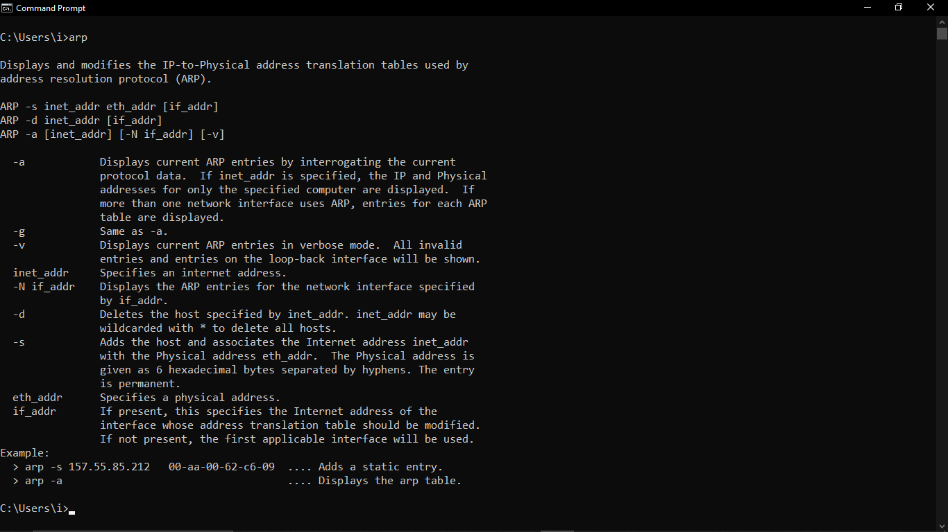

* arp -a

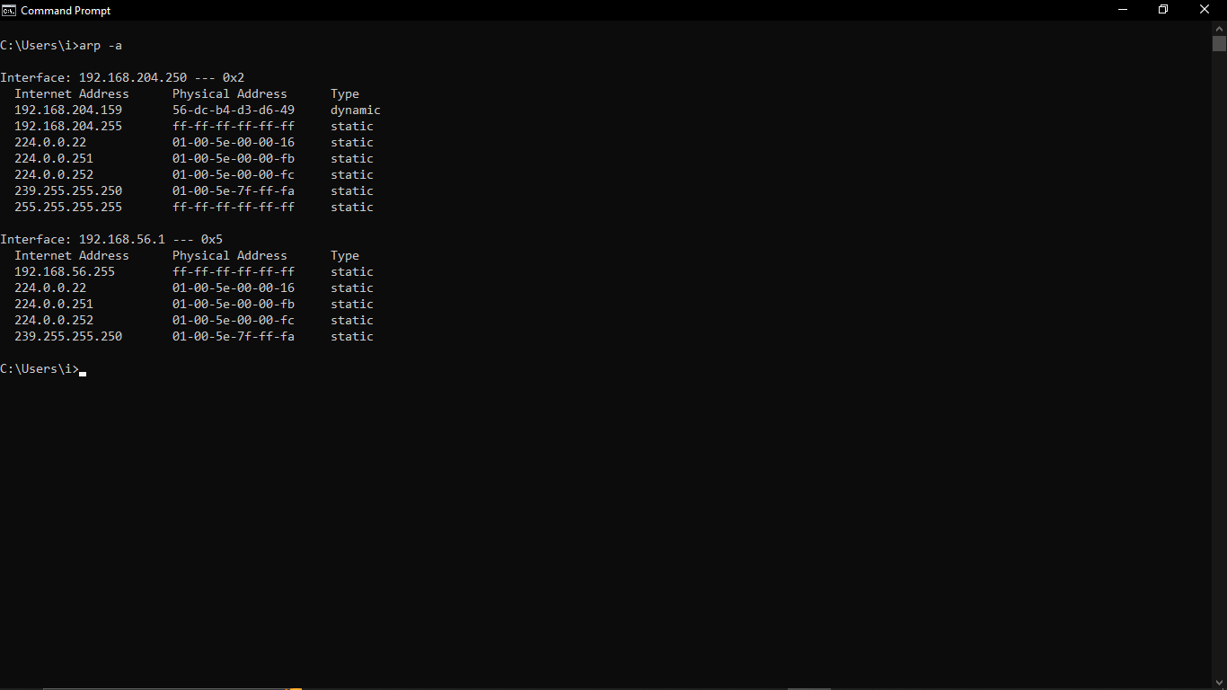

* arp –a

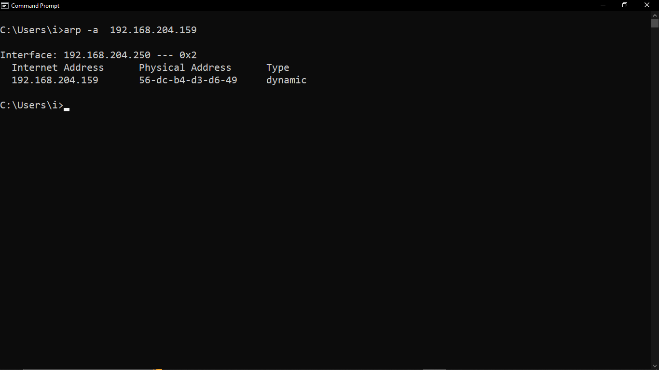

* arp –a –v

